WORLD MARATHON

CHALLENGE 2017

 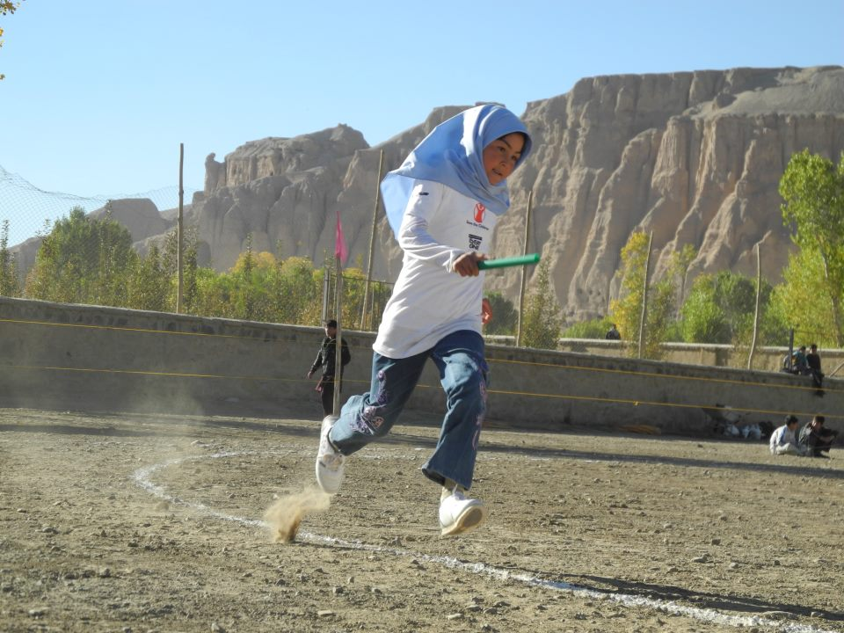

**Launch Week is 2nd- 6th October 2017**

SAVE THE DATE - FREE ENTRY!

Join hundreds of others around the world by taking part in the World Marathon Challenge, a relay event where teams of 26-36 runners try to break the world marathon record. Each team competes at their own venue where team members’ take turns running 200 metre legs until the full 26.2 mile distance is completed.

The results from around the world are entered on the race [website](http://website.www.competitioncentre.net):[**www.competitioncentre.net**](http://www.competitioncentre.net)

The Finals week will be on 11th – 15th June 2018 but teams can compete and enter their time at any point between 2nd October – 15th June..

Younger children can take part in the **WORLD 5000M CHALLENGE** a relay event in which teams are challenged to beat the 5000m world record.

**For more information and to register please visit** [**www.competitioncentre.net**](http://www.competitioncentre.net)

|  |  |  |  |
| --- | --- | --- | --- |
|  | **Supported by** | AMATEUR ATHLETIC ASSOCIATION |  |

The World Marathon Challenge is supported by British Athletics and qualifies entrants for the British Athletics Endurance Team Awards. You can also use the Individual Endurance Awards to prepare for the event. More information about the British Athletics Endurance Awards can be found at[**www.sportshall.org/endurance**](http://www.sportshall.org/endurance)



