WORLD 5000 METRE
CHALLENGE 2017
For the Primary School Age Group

ORGANISERS GUIDE

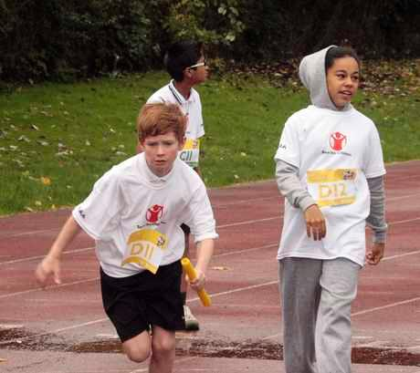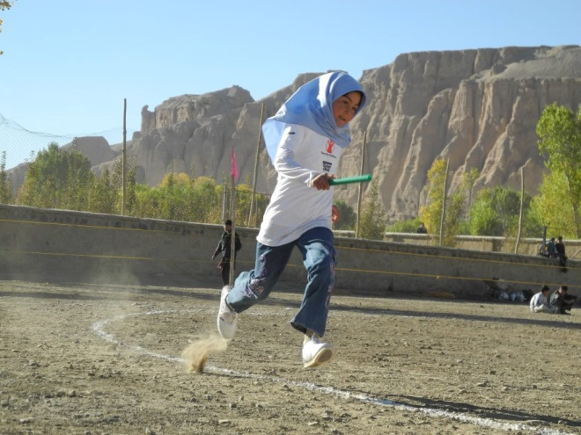

Supported by




WORLD 5000 METRE CHALLENGE

WHAT IS IT?

The World 5000 Metre Challenge is aimed at primary schools around the world. It is a simple and fun competition to organise and aims to link the participating teams together as part of our International Community.

A TRULY GLOBAL EVENT
The World 5000 Metre Challenge is a simultaneous relay in which primary school teams from across the world race against each other to complete 5000 metres and your school can be part of it. It will take place in parallel with the World Marathon Challenge and the challenge for primary schools is to beat the 5000m world record set by Kenenisa Bekele of 12 minutes 37.35 seconds

WHO CAN TAKE PART?

The event is for teams of children aged 7 to 11 on the day of the event.

The minimum team size is 10 children with each team member running 5 times over a 100m distance. No child should run more than 5 times.

There is however, no maximum team size so all the children in your class can be in the team or why not divide the class into different teams to create an exciting competition.

For children who don’t wish to run there are other ways in which they can be involved acting as team managers, timekeepers, etc. (see diagram for details)

Teams can either be mixed (a minimum of 5 Boys or 5 Girls to qualify as a mixed team) or all girls and all boys and there is also a category for ‘any age’ if younger or older children wish to take part.

In addition to school teams, teams are welcome to enter from other organisations such as the scouting movement and youth clubs.

TAKING PART STEP BY STEP

- Choose a date and venue for your World 5000 Metre Challenge event.
- Register your team(s) online at www.competitioncentre.net and challenge other teams to take part too, for example, a school or club from your twin town.
- Publicise your event.
- Set up your event on a running track or in a field with the 5000 metre distance divided into 100m sections (see diagram for details).
- RUN! Each team member runs 100m before passing the baton on. Keep going until the whole 5000 metres has been covered.
- Enter your final times and share photos and stories through our Twitter and Facebook accounts.

REGISTER YOUR TEAMS, LOG YOUR RESULTS AND SEE YOUR PLACE ON THE WORLD LEADERBOARD AT www.competitioncentre.net

WHEN?

We know schools have busy schedules so this year we are keeping the competition open until 15th June. Simply pick a date that suits and run.

Our official Launch week will be the week commencing 2nd October 2017.
Our Finals week will be the week commencing 11th June 2018.

The opportunity exists to utilise the Finals week as a second trial with your team competing against their time set earlier in the year.

HOW IT WORKS?

The 5000 metre distance is divided into 50 sections of 100 metres each.
Each team member completes one 100 metre section before passing the baton to the next runner.
Each runner completes a maximum of 5 sections.
Runners should wear race numbers to identify their position in the relay sequence.

INVOLVE EVERYONE

Invite your whole school to be part of the event – not just the runners. The race itself can be organised by around a dozen young officials and there are many other ways for students to get involved:

Photography and film Local press
Social media or blogging lnternal communications
Guest hospitality

FUNDRAISING

The competition is free to enter. There is no obligation to collect for any charity but the World 5000m Challenge provides an excellent opportunity to raise money for a good cause.

COMPETITION CENTRE

This worldwide race comes alive at www.competitioncentre.net where you can:
- Register your venue and team details
- View your team on the map alongside hundreds of others from all over the world
- Enter your finishing times
- See where you’re ranked against other teams around the world

ON THE DAY

WHAT YOU WILL NEED

- A large open space or running track
- Cones or markers to mark out the track
- 10 or more runners per team, up to 5 teams wearing different colours
- Race numbers (pdf available online)
- Recording sheets (available online) and pens for Officials
- 1 Lap indicator board per team
- 1 Baton per team
- 1 Stopwatch per Time Keeper
- First Aid Kit
- Internet Access to log and view live checkpoint times and results if possible.

RACE OFFICIALS

- Race Organiser: starts the race, ensures all teams follow the rules and logs results online.
- Timekeepers: time and record race completion time (one per team)
- Lap Counters: operate a simple lap-counting board to show the number of laps their team has completed (one per team)
- Team Managers: Each team will require two team managers to ensure that their team members are in place in the correct sequence for each take-over.
- Other roles: There are many other ways in which children can be involved, for example: photographer, announcer, reporters, cheering squad, caterers etc.

ONLINE RESOURCES

We’re here to help you make your event a huge success. There are lots of resources you can download from our website www.competitioncentre.net
- World 5000 Metre Challenge race numbers
- Certificates for runners
- Posters to promote the event in your school and beyond
- Judges’ and Time Keepers’ recording sheets

CHILD SAFEGUARDING
The safety and wellbeing of children is paramount, you must ensure that at all times the appropriate level of supervision and care is being provided by responsible adults to enable every child to have a fun, and most importantly, safe day. A set of guidelines on child safeguarding can be found at www.britishathletics.org.uk/governance/welfare-and-safeguarding/guidance-documents-and-resource

FIRST AID
Local Organisers will be responsible for ensuring that a qualified first aider is present at their event.

LIABILITY
The promoting partners, the Amateur Athletic Association and Eveque are not hosting these events. They therefore cannot accept any liability should you decide to organise an event, including for the travel, security (including, but not limited to, personal property and medical), health and safety, or otherwise for you, your fellow organisers and the children taking part in the event. Please ensure that the participants and your fellow organisers understand this.

STAY IN TOUCH

To keep up to date with the latest news in the run-up to, during and after the event, you can:
- Join us at www.facebook.com/EvequeWorldMarathonChallenge
- Follow us on Twitter: @EvequeWMC
- See who else has entered, enter and view results: www.competitioncentre.net
- Contact us by email: support@eveque.co.uk

OUR PARTNERS

The World Marathon Challenge is delivered by Eveque in partnership with Sportshall Associates, Amateur Athletic Association and England Athletics.

We would like to acknowledge the kind assistance of the Amateur Athletics Association for its support and funding during the first seven years of this event.

We would also like to thank our other partners and supporters.

