WORLD MARATHON
CHALLENGE

ORGANISERS GUIDE

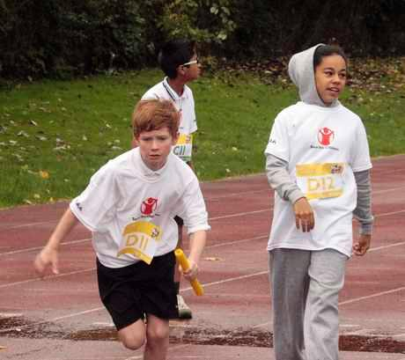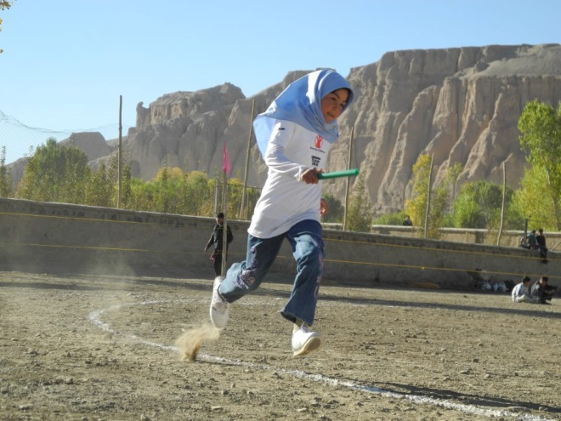

Supported by



WORLD MARATHON CHALLENGE

WHAT IS IT?

The World Marathon Challenge is an annual event for schools, clubs and communities around the world. It is a fun competition which is simple to organise and aims to link the participating teams together as a world-wide shared sporting experience.

Every year schools and clubs from Canada to Finland and from France to Romania compete against each other and look to beat the world marathon record.

The World Marathon Challenge is a simultaneous relay in which teams from across the world race against each other over the full marathon distance – and your school can be part of it.
The World Marathon Challenge began in 2008 and became so popular that by 2013 it was the largest event of its kind ever staged. From a pristine indoor running track in Manchester to a forest path in Mexico to a grassy field marked with a painted white line in Kenya. Even children in a refugee camp in Syria have taken part.

The challenge is for teams to beat the world marathon record and as the world’s top athletes continue to better this, so the challenge becomes a little harder each time. Currently Dennis Kimetto holds the world record with a time of 2 hours 2 minutes and 57 seconds.

TAKING PART STEP BY STEP

- Choose a date and venue for your World Marathon Challenge event.
- Register your team(s) of around 15 girls + 15 boys plus a captain (teams can be a minimum of 26 athletes and a maximum of 36 athletes) online at www.competitioncentre.net.
- Publicise your event.
- Maybe challenge other teams (including you Twin Schools) to take part too.
- Set up your event on a running track or in a field, with the marathon distance divided into 200m sections, plus an opening leg of 195m (This Organisers guide has full instructions). The event can be held on a standard oval running track or on an accurately measured irregular or linear track.
- RUN! Each team member runs 200m before passing the baton on. In total each runner completes between six and eight legs while wearing a race number to identify their position in the sequence.
- Record checkpoint times throughout the race and log them online.
- Enter your final times and share photos and stories through our Twitter & Facebook accounts.

REGISTER YOUR TEAMS, LOG YOUR RESULTS AND SEE YOUR PLACE ON THE WORLD LEADERBOARD AT www.competitioncentre.net

WHEN?

We know schools have busy schedules so this year we are keeping the competition open all year round. Simply pick a date that suits and run.

We will hold a Finals week which will provide an opportunity for a second trial with your team competing against their time set earlier in the year.

TEAM CATEGORIES

- Mixed gender (aged 11 to 13 years)
- All Boys Teams (aged 11 to 13 years)
- All Girls Teams (aged 11 to 13 years)
- Open Category (any age, even adults!)

All single gender schools may partner with another school to make mixed gender teams
Mixed gender teams must run alternate boy/girl team members.

PRIMARY SCHOOLS
We recommend that primary school aged teams enter the World 5000m Challenge instead (more information about this can be found on the website)

FUNDRAISING

The competition is free to enter. There is no obligation to collect for any charity but the World Marathon Challenge provides an excellent opportunity to raise money for a good cause.

COMPETITION CENTRE

This worldwide race comes alive at our online Competition Centre, where you can
- Register your venue and team detail.
- View your team on the map alongside hundreds of others from all over the world.
- Enter your finishing times and check times at 6,000m intervals.
- See where you’re ranked against other teams around the world.

Register now for free at www.competitioncentre.net

WHAT YOU WILL NEED
- A large open space or running track
- Cones or markers to mark out the track
- Up to 5 teams wearing different colours can be accommodated on a single track
- Race numbers (pdf available online)
- Recording sheets (available online) and pens for Officials
- 1 Lap indicator board per team
- 1 Baton per team
- 1 Stopwatch per Time Keeper
- First Aid Kit
- Internet access to log and view live checkpoint times and results if possible

RACE OFFICIALS
The race can be organised by a core team of 12 volunteers or students or you could choose to involve more people to give your event even greater impact.

Recommended numbers of organisers for the relay itself are as follows:

 | 2 team race | 3 team race | 4 team race
Race Organiser | 1 | 1 | 1
Referee | 1 | 1 | 1
Judges | 2 | 3 | 4
Time Keepers | 2 | 3 | 4
Lap Board Operators | 2 | 3 | 4
Team Manager | 4 | 6 | 8
Total | 12 | 17 | 22
OFFICIAL DUTIES
- Race Organiser: The Race Organiser will liaise with the Referee, Judges and Timekeepers, and transmit check times to Race Control.
- Referee: The Referee will be responsible for making sure that teams adhere to the rules and that the Judges, Time Keepers and Lap Board Operators ensure that each team covers the correct distance.
- Judges: The Judges must record the laps completed by each team as the relay progresses. They must also ensure that team managers are controlling the take-overs.
- Time Keepers: The Time Keepers should record the cumulative times for each team at the end of each lap acting as a cross-check against the Judges and Lap Board Operators. They must also inform the race organiser of the times at the specified check points.
- Lap Board Operators: We recommend that a separate lap board is provided for each team. Lap Board Operators are responsible for ensuring that the lap board assigned to their team always shows the correct number of ‘laps to go’. Each lap board should be clearly marked (preferably colour-coded) so that it is clear which board belongs to which team.
- Team Managers/Takeover Monitors: Each team will require two Team Managers to ensure that their team members are in place in the correct sequence for each take-over.

ONLINE RESOURCES

We’re here to help you make your event a huge success. There are lots of useful resources available for download from our website www.competitioncentre.net including:
- World Marathon Challenge race numbers
- Certificates for runners*
- Posters to promote the event in your school and beyond
- Judges’ and Timekeepers’ recording sheets
- Guide to qualifying for British Athletics Awards

CHILD SAFEGUARDING
The safety and wellbeing of children is paramount and you must ensure that at all times the appropriate level of supervision and care is being provided to enable every child to have a fun and, most importantly a safe day. Child safeguarding guidelines can be found at www.britishathletics.org.uk/governance/welfare-and-safeguarding/

FIRST AID
Local Organisers will be responsible for ensuring that a qualified first aider is present at their event.

LIABILITY
The promoting partners the Amateur Athletic Association and Eveque are not hosting these events. They therefore cannot accept any liability should you decide to organise an event, including for the travel, security (including, but not limited to, personal property and medical), health and safety, or otherwise for you, your fellow organisers and the children taking part in the event. Please ensure that the participants and your fellow organisers understand this.

STAY IN TOUCH

To keep up to date with the latest news in the run-up to, during and after the event, you can:
- Join us at www.facebook.com/EvequeWorldMarathonChallenge
- Follow us on Twitter: @EvequeWMC
- See who else has entered, enter and view results: www.competitioncentre.net
- Contact us by email: support@eveque.co.uk

OUR PARTNERS

The World Marathon Challenge is delivered by Eveque in partnership with Sportshall Associates, Amateur Athletic Association and England Athletics.
We would like to acknowledge the kind assistance of the Amateur Athletics Association for its support and funding during the first nine years of this event.

